I have created the back-end data repository for a “Crypto-Dashboard” front-end that I will build out over time. There are many websites out there that recycle the same exchange price and volume indicators, however, there are a number of fundamental and sentiment indicators that I use today for trading crypto, that could be very useful if automated and presented in the right way. I’ll be constructing a database to hold the historical information from various sources that I will use in the future for my “Crypto-Dashboard”.

**Aggregate Exchange Volume**

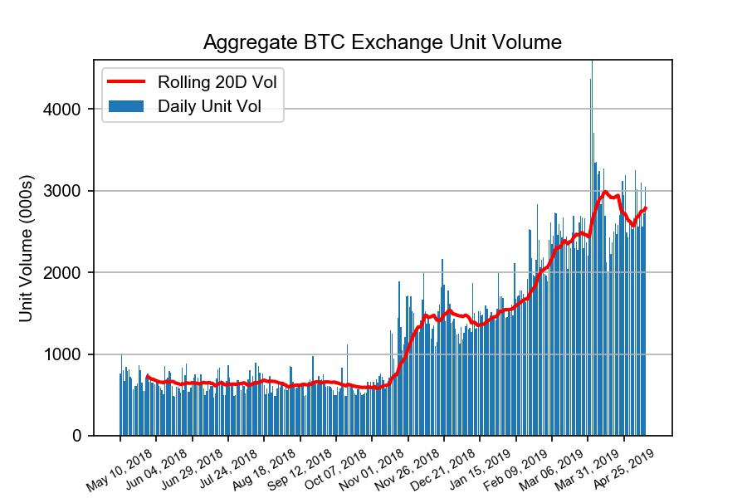Volume is extremely important to technical analysis and the Bitcoin market is very fragmented with hundreds of exchanges around the world. Bitcoin is traded 24/7 globally and Asia has a large share of trading Bitcoin so frequently the big move will occur in Asia overnight. The good news is that there is a website called CoinMarketcap.com that aggregates total exchange volume and even adjusts it for some bad players whose volume is overstated. CoinMarketcap even has an API however unfortunately the aggregate exchange volume is not available from the API so I used Python to scrape it from a table in the site and then I used Matplotlib to graph it (see graph on left). This scrape gave me not only the volume but aggregate BTC pricing, volume weighted across all exchanges which is a series I can use for many other charts. I will also run this scrape on the other large cap cryptos like ETH, BCH, and LTC.

**Bitfinex Bitcoin - Leveraged Longs and Margin Shorts**

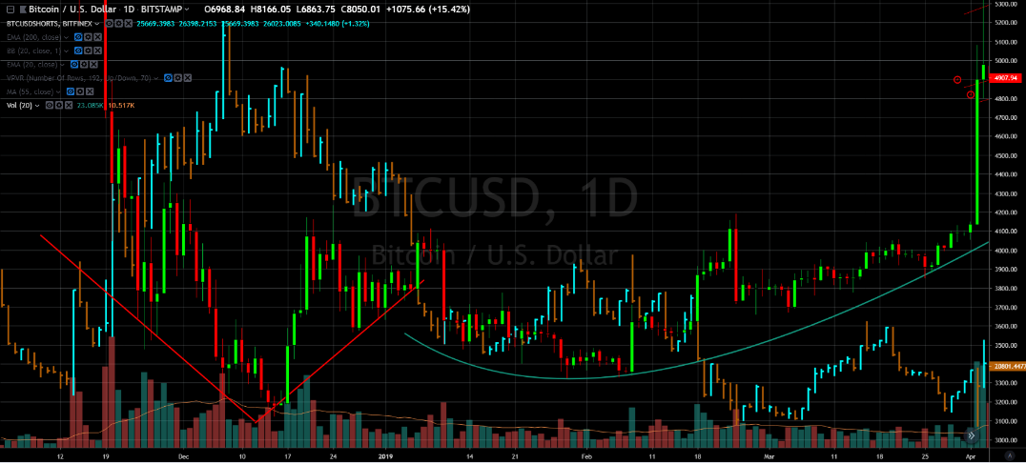Bitfinex is an exchange that allows margin and short trading and actually releases the statistics on how many leveraged and short positions of Bitcoin are outstanding at any given time. I’ve seen time series of this data used on Tradingview and other places, as an indicator, but have always felt it could have more utility. The below chart is Bitfinex short contracts outstanding (blue and brown bars) on top of a standard BTC one day price chart and as you can see they are somewhat inversely correlated. What I would like to do is show the outstanding shorts relative to Bitfinex daily trading volume- a days to cover metric overlaid on a Bitcoin price chart. I had difficult finding the time series anywhere and the Bitfinex API would only give me the longs and shorts with a 1m interval over a 2 hour timeframe. I couldn’t scrape it from Tradingview because it was showing the data in some kind of flash rendering that hindered the inspector. So I broke down and manually entered the data for a 7 month time frame for longs, shorts, and bitfinex volume. However, I also set up a Google App Script (java script) in a Google sheet with a time- based trigger to do the API request each day at close. I’m sure I will be using this metric for a long time and will soon have all the data I need. The javascript for this, is in the file bitfinex_API_daily_close.gs, that is located in my ETL git.

**Bitcoin Dominance Ratio**

This metric is BTC market cap/total crypto capitalization and helps you identify periods of Bitcoin outperformance vs alt coins and vice versa. The relevant metrics for this ratio is:

BTC total capitalization/crypto market total capitalization

To calculate total cap of BTC we need price and total outstanding coins. I found BTC total supply outstanding as a CSV download from blockchain.com and I have the closing price of BTC each day from my Coinmarketcap.com table scrape. Total capitalization of the whole crypto industry is available on coinmarketcap.com but unfortunately it’s not available as a free API and it’s not in a table format. When you pull up the market capitalization table on the site for a specific day, all the coins are listed in the table with their corresponding cap. Under the table is one line with the total crypto market capitalization, for the day you requested. So, easy-peasy, just put in a request for each day and scrape the total cap at the bottom? Except, it seems they time you out after 6 scrapes. To subvert this I added a random number of scrapes up to 6, followed by random length pause, and that seems to be doing the trick!

**Description of Files**

**CSV files:**

1. **crypto_total_cap.csv** – one series (and date) total crypto industry ( all coins) total industry market cap scrape from coinmarketcap.com
2. **3Y_BTC_5-15-19.csv** – Aggregate exchange info on Bitcoin across all exchanges in table scrape from coinmarketcap.com (even the price is volume weighted avg). This file has 8 separate time series (plus date): BTC Open, High, Low, Close, Volume, Market Cap, Unit Volume, and a 20D moving average unit volume.
3. **Total_bitcoins.csv –** Only one series on this one, total Bitcoin supply (plus date).
4. **Bitfinex_l-s-v.csv** – Bitfinex leveraged longs, margin shorts, and bitfinex volume (plus date)

**Code files:**

1. **Coinmarketcap_API.pynb** – Jupyter Notebook that has most of the different scrapes and API calls in the windows.
2. **bitfinex_API_daily_close.gs** – Javascript that runs in Google sheets to download the bitfinex closing longs, shorts and volume each day at market close.
3. **Crypto_Dash_Create_DB.pynb** - the Jupyter Notebook that creates the SQL database.